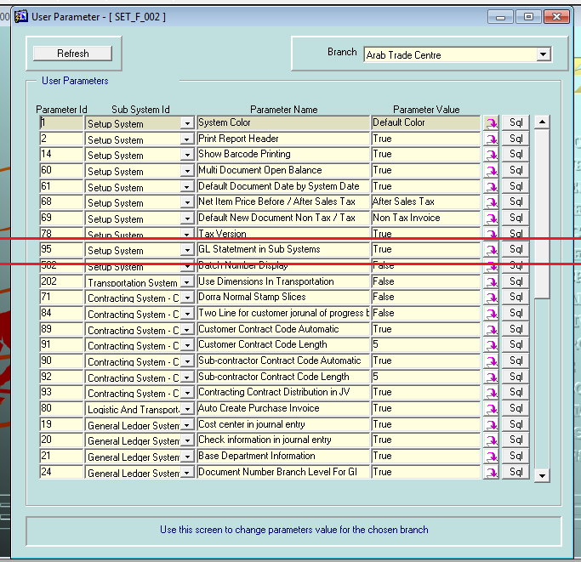

When u make this parameter true

supplier open balance disappear in sales system

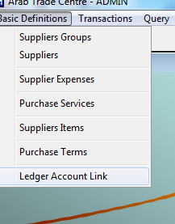

Statement of accounts in purchase replaced by statements of account in GL

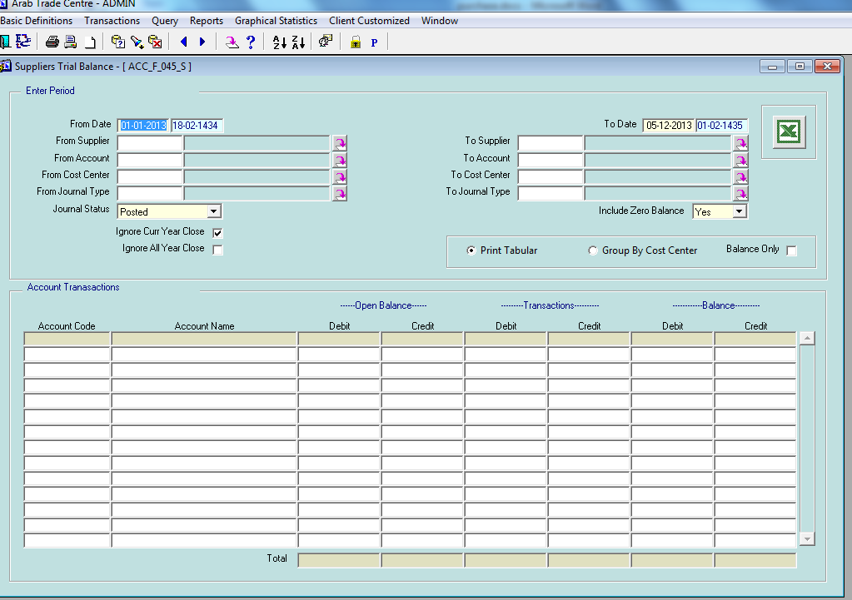

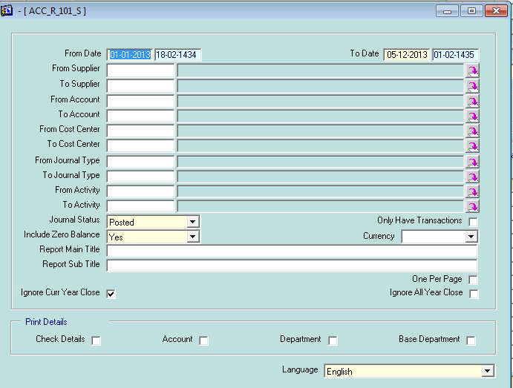

New method for purchase fixed assets with purchase cycle

In this version we have 2 methods that we can use for added fixed assets (our clients can work by both for the same company and there is no need to force our client to chose one method):

**Method 1 (old method)**

1. added fixed assets manually in Fixed Assets system
2. create invoice for assets added from fixed assets system

problem with this method that u can not apply purchase cycle when u want to purchase fixed assets like make purchase quotation, purchase order, etc,…

**Method 2 (new method)**

1. define fixed assets template in purchase using this new form

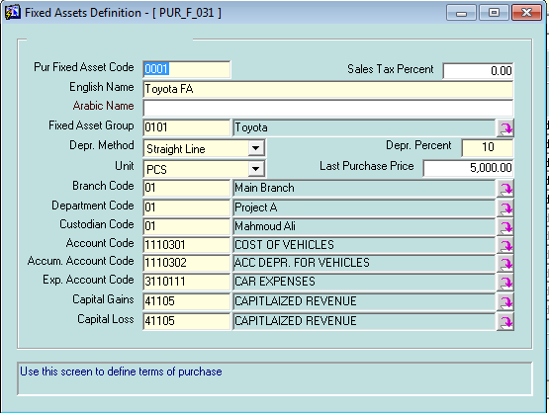

1. make the complete cycle of purchase we currently have like purchase quotation, purchase order, purchase invoice, etc,… this documents is adjusted to allow purchase both services and fixed assets and they can both purchased in one invoice, the fixed assets will be marked by different colors as shown

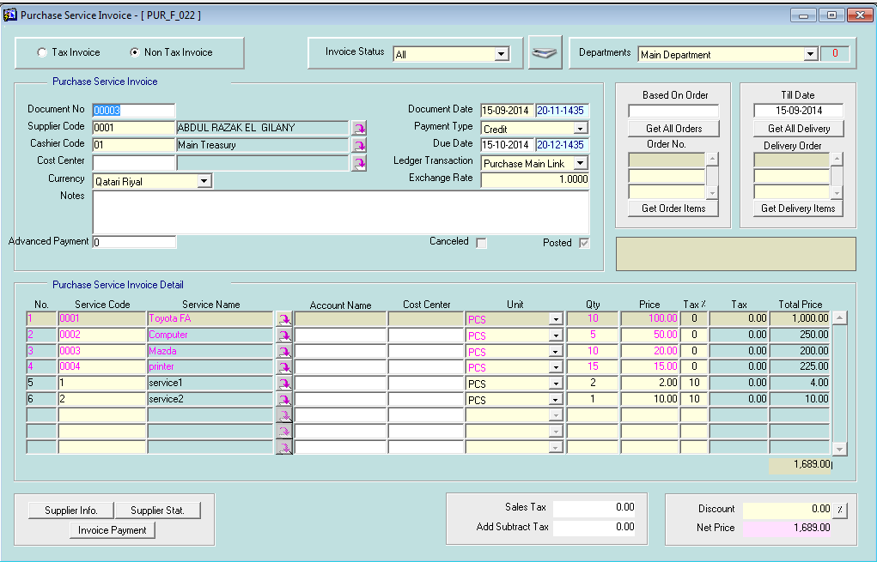

1. new screen newly developed allow u to added the assets purchased to fixed assets system automatically and keep tracking for assets purchased and still not added to fixed assets system

it also shows u the quantity of assets purchased and the matching qty for assets added to fixed assets system based on it.

Suppose u purchase 10 computers u can

* added 10 assets in fixed assets system by pressing “add one by one” button (this will create 10 fixed assets)
* added one assets with Qty 10  by pressing “add by total” button
* u can also added by combination of different qty like 3, 5 and 2 by adjusting in the block down.

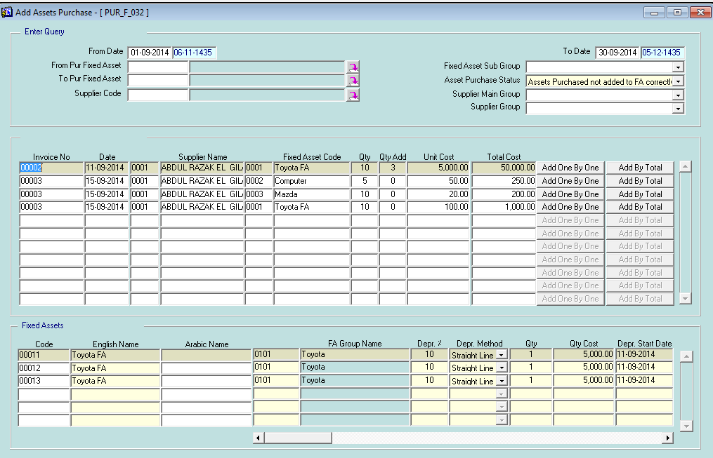

1. this will create new assets in fixed assets system as shown

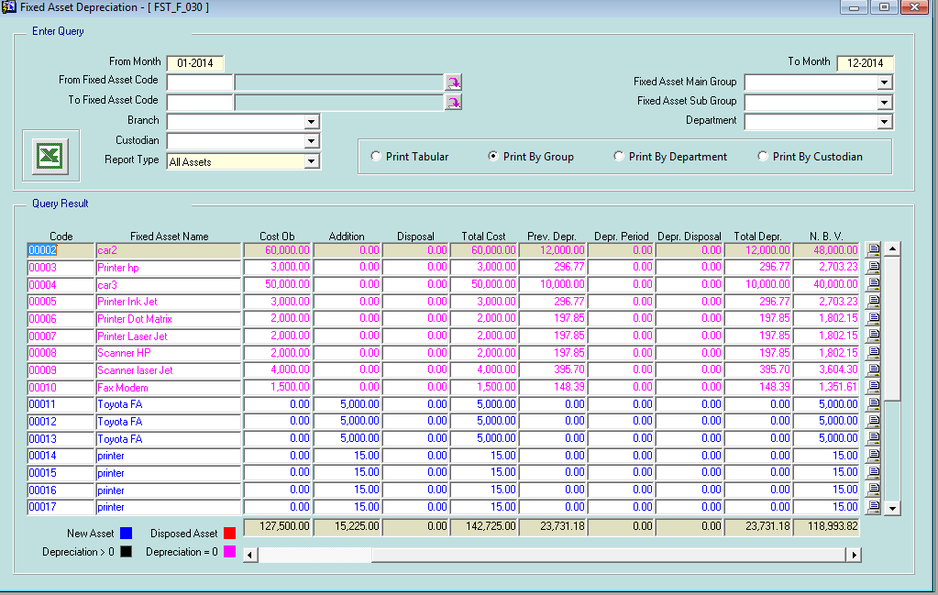

1. for those assets that created from purchase cycle the system will mark them so u can’t make purchase invoice for them from fixed asset system.

This means u can work in both method for the same company and not force our client to chose one method of them.